Analysis of Coffee Chain Operations & Profitability

Using Tableau

Submitted to Prof. Srinarayan Sharma in partial fulfilment of Business Intelligence Course

Group 11
Deepak Kumar PGP13020
Rishi Verma PGP13046
Bhaghat G PGP13079
Rakesh Krishna V PGP13108
Rakesh Sukumar PGP13134

Profitability Analysis – Coffee Chain
Profit is the difference of Revenue and Cost. Revenue is obtained through sales of products and cost can be further broken down to Cost of Goods Sold (COGS) and Total Expenses. Total expenses can be further broken down to Marketing expenses and other expenses which include inventory expenses among the other things. The below table represents this structure. Profit for the business can be better understood by analyzing each of the above components separately.
Coffee chains products are broadly classified into two product lines; namely “Beans” and “Leaves”. “Coffee” and “Espresso” product types are classified under Beans and “Herbal Tea” and “Tea” product type are classified under Leaves. All products of Coffee chain are listed under one of the above four product types as listed below.
Product Line | Product Type | Products
Bean | Coffee | Amaretto
Bean | Coffee | Colombian
Bean | Coffee | Decaf Irish Cream
Bean | Espresso | Caffe Latte
Bean | Espresso | Caffe Mocha
Bean | Espresso | Regular Espresso
Leaves | Herbal Tea | Chamomile
Leaves | Herbal Tea | Lemon
Leaves | Herbal Tea | Mint
Leaves | Tea | Darjeeling
Leaves | Tea | Earl Grey
Leaves | Tea | Green Tea

Modelling

The above approach helps to break the problem at hand i.e. to identify why the coffee chain is having low profits into many smaller questions which can be answered by analyzing the provided data. Data analysis has been carried out mainly in four domains as depicted in the figure below:

Product Performance against target: One reason for low profitability for the company may be low or negative profits in certain products. To check whether this is in-fact the cause. We analyzed the profitability across the product lines comparing actual values of sales, profits, margin, cogs etc against budgeted values.

Region wise product performance: Low profitability of the business may also be due to poor performance of some or all products in certain markets. A region wise analysis is performed to verify this.

Effect of Marketing: Effect of marketing on sales and profits to verify how fruitful the marketing efforts of the company are and also to find out if huge marketing expenses are the reason for low profits.

Inventory management: Inventory cost is one of many the components that make up the “other expenses”. Judicious management of inventory is necessary to reduce inventory costs and loss of sales opportunities and can lead to better profits for the business. The coffee chain maintains inventory at each of the many locations that it operates. Inventory levels at each location is analyzed against the business at that location to derive insights.

Analysis of Product wise Profitability
Product wise profitability is analysed by drilling down from overall profit margins, COGS and Total expenses of Whole company to each and every product coffee chain is offering
Overall Company statistics
 | Year
 | 2012 | 2013
COGS as % of Total Sales | 44.70% | 42.84%
Total Expenses as % of Total Sales | 28.92% | 27.15%
Profit Margins | 26.38% | 36.72%

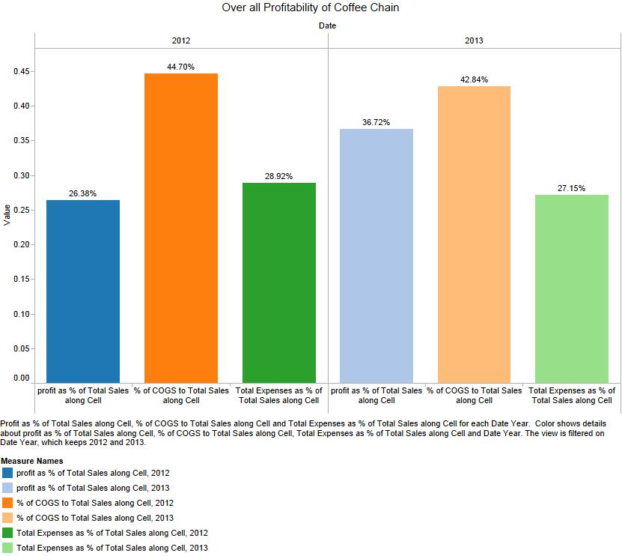
Comparing results across years 2012 and 2013 we can see overall profitability of Coffee chain increased from 26.38% to 36.72%. COGS and Total Expenses as percentage of Sales as well decreased from 2012.

Profitability in Product Lines
When drilled down to product lines we found that profit margins for both product lines Beans and Leaves are remained almost same. Although Beans is slightly better than Leaves.
Also from 2012 to 2013 the profit margins for both the product lines have increased and also COGS and Total expenses as percentage of Sales decreased from 2012 in both product lines. Below plot shows the Product Line profitability in years 2012 and 2013

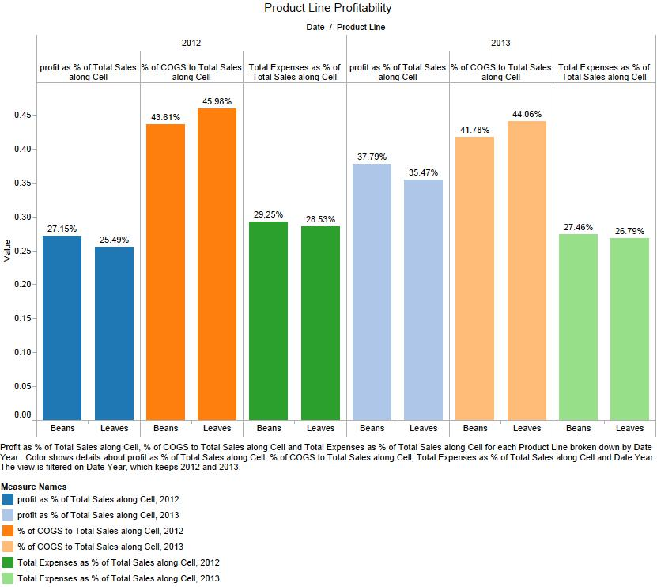

Profitability in Product Types
When drilled down to product types we found that profit margins for all the product type Coffee is better than Espresso, Tea and Herbal Tea. Product types Espresso, Tea and Herbal Tea has almost same profit margins
Profit Margins increased for all product types from 2012 to 2013 also COGS and total expense per Sales ratios decreased from 2012 to 2013 improving profitability of all the Product types

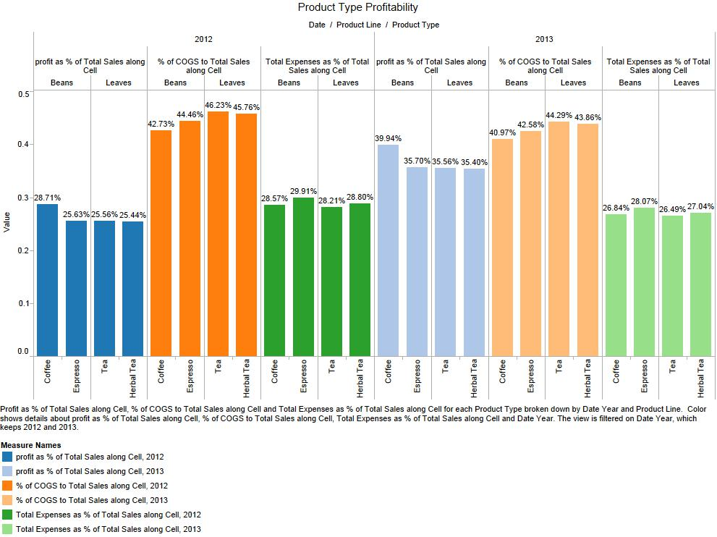

Profitability in Products
When drilled down to individual products we found that profit margins of products Colombian, Regular Espresso, Chamomile and Darjeeling are highest in each product type Coffee, Espresso, Herbal, Tea and Tea respectively.
We can also observe that Amaretto, Caffe Mocha, Mint and Green Tea have lowest profit margins in their respective Product types
Profit Margins increased for all product types from 2012 to 2013 also COGS and total expense per Sales ratios decreased from 2012 to 2013 improving profitability of all the Product types
Except for Green Tea we can see improvement in profit margins for all the products when compared to 2012. COGS and Total expense for all the products decreased from 2012 to 2013 which have aided profitability.
Product wise profitability is shown in below plots.
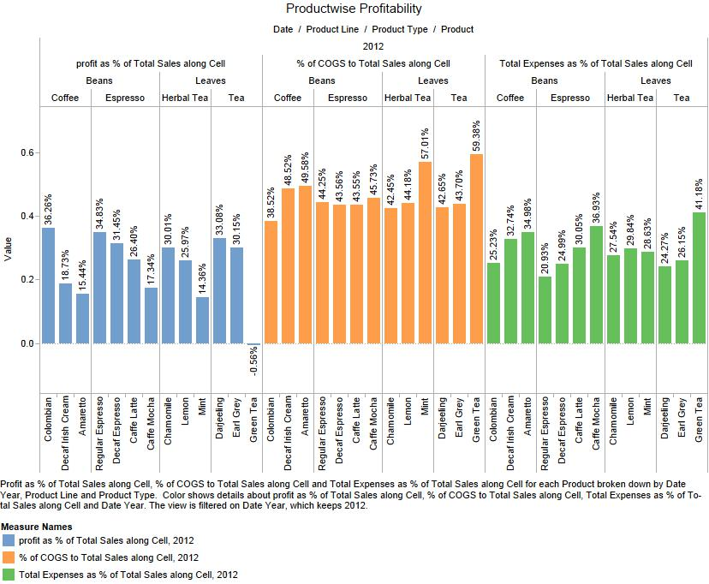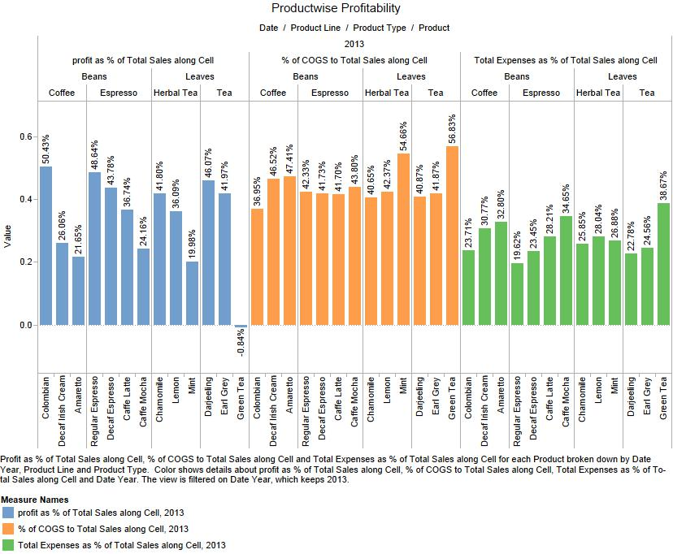

Comparison of actual Performance with Budgeted performance
Coffee chain central office has defined benchmark financial performance with its planned budgeted values. In current section actual performance is compared with budgeted performance by comparing profit margins and gross margins for product lines, product types and products. Difference of actual profit margins and budgeted profit margins and difference of actual gross margins and budgeted gross margins are plotted for comparison analysis.

Actual Vs Budgeted performance of Product Lines

In 2013 we can observe that for product line Leaves actual gross margins and profit margins are greater than budgeted gross margins and profit margins. On the flipside Beans product line is underperforming than benchmarked performance in terms of both gross margin and profit margin.
In 2012 actual gross margins out performed budgeted gross margin of product line Leaves.
When compared with 2012 in 2013 actual profit margins improved for both product lines when compared with budgeted profit margins. But actual gross margins for both products decreased when compared with budgeted gross margins.
Below plot shows the above described results
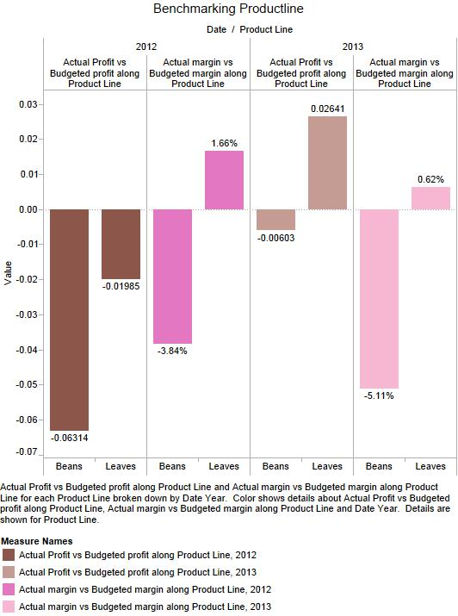

Actual Vs Budgeted performance of Product Types
In 2013 we can observe that product types Coffee, Espresso and Tea have better actual profit margins than budgeted profit margins. But for Product type Herbal Tea actual profit margins are worse than budgeted profit margins. All the Products lines have lower actual gross margins than budgeted gross margins.
In 2012 we can observe that none of product line’s actual profit margins is better than budgeted profit margins. Only Espresso’s actual gross margin outperformed budgeted gross margin. For rest of product types actual gross margins are less than budgeted gross margins.
Below plot shows the above described results

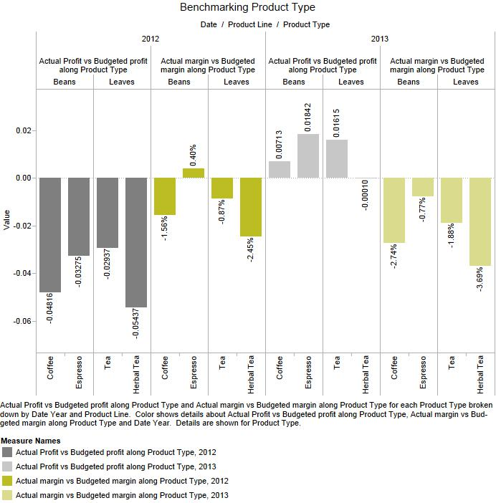

Actual Vs Budgeted performance of each Products
In 2013 we can observe that products: Colombian, Regular Espresso, Decaf Espresso, Caffe Latte, Chamomile, Lemon, Earl Grey and Darjeeling have better actual profit margins than budgeted profit margins. Whereas products: Decaf Irish Cream, Amaretto, Caffe Mocha, Mint and Green Tea have lower profit margins than budgeted profit margins. Except for Caffé Latte all the products have lower actual gross margins than budgeted gross margins.
In 2012 we can observe that all products have lower profit margins than budgeted profit margins. And only products Colombian, Amaretto and Caffe Latte have better actual gross margins than budgeted gross margins.
From 2012 to 2013 we can observe that more and more product’s actual performance is better than budgeted performance showing that operations of coffee chain are improving
Below plot shows the above described results
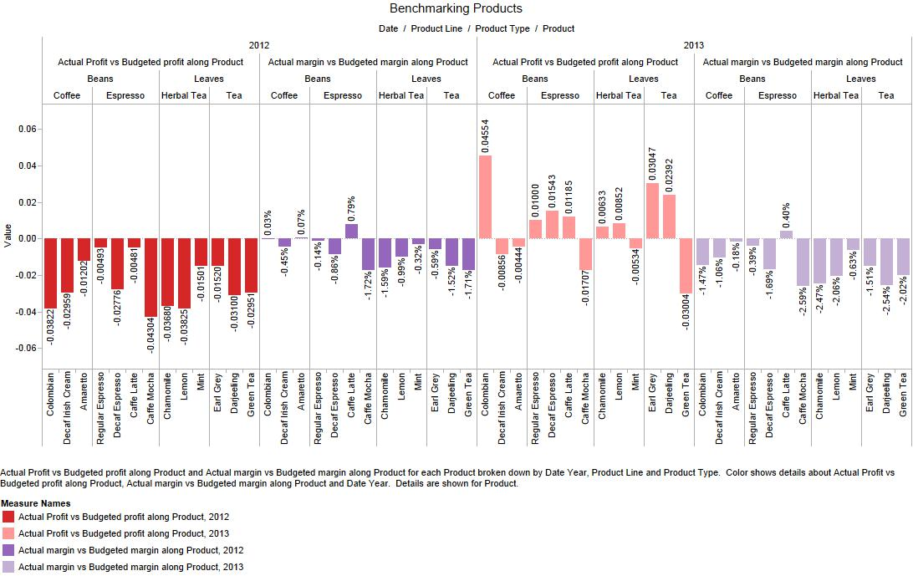

Region wise product Performance
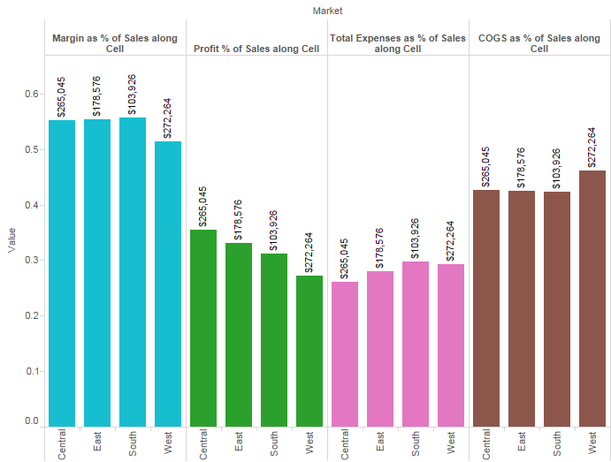
The above figure depicts that profitability (green coloured bars) varies across different regions with west being the least profitable regions. This calls for additional efforts to identify loss making products in each market, find out causes for low profitability and take remedy actions to improve overall profitability.
Next, the top five profit making and all loss making markets for each product was identified using data visualization capabilities of Tableau. The filtering option enables using same report to analyze all products as shown below:
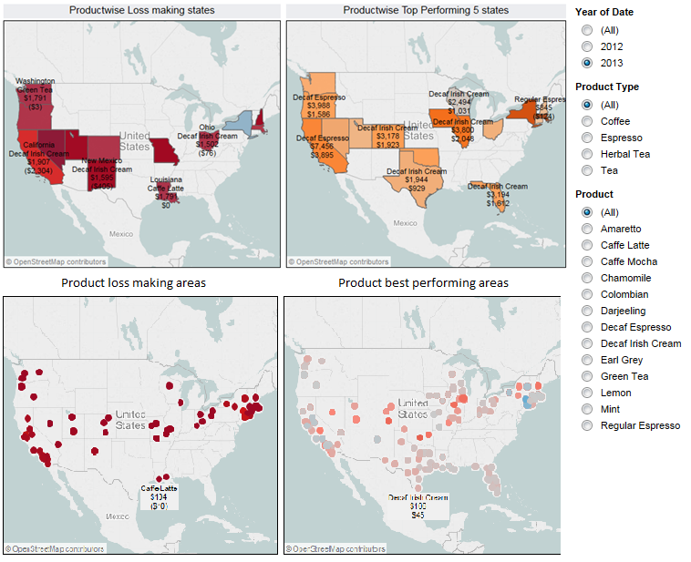
Next, for each product, the reason for bad performance was identified using the below chart. For example, for product Ameretto, in California, the margin is negative (see bar chart) which means the product is sold at a price less than its cost (variable cost).
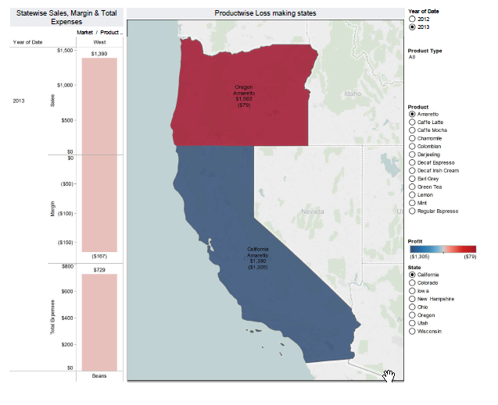
Another example is that of product Caffe Latte in New Mexico. Here though the margin is positive the profit is negative because expenses are higher than margin.
Similar analysis can be carried out of all product and yields below results for products making losses in different regions.
Product | States
Amaretto | Oregon, California
Caffe Latte | New Mexico, Louisiana
Caffe Mocha | New Mexico, New Hampshire, New York
Chamomile | Missouri
Colombian | Nevada
Darjeeling | Utah
Decaf Irish Cream | California, New Mexico, Ohio
Earl Grey | Missouri
Green Tea | Washington, Nevada, Utah, Missouri
Lemon | Colorado, Missouri, New Hampshire
Mint | Utah, New York
Regular Espresso | New Hampshire

Marketing Insights
The below figure shows product wise figures of sales, profits and marketing expenses for 2012 and 2013 combined

Interpretation
- Columbian coffee has the highest sales and profits for a 13.2% marketing expense over sales. It is the best product in terms of profitability and the marketing budget well spent.
- Marketing expenses of products Café Mocha, Green Tea and Mint are higher than the profits
Analysis of marketing budgets of some of the products and the regions in which they are operating
Columbian Coffee
- Columbian coffee has the highest sales and profits for a 13.2% marketing expense over sales. It is the best product in terms of profitability and the marketing budget well spent
- It is also the most profitable product and it is also the product with the highest sales
- Its profit as a % of sales increased significantly from 36% to 50% and the sales by 4.5% from 2012 to 2013. This happened in spite of the marketing expense remaining unchanged. This happened manly because of decrease in total expenses
- California, New York, Massachusetts and Texas are the best markets for the products with very high sales. But the marketing expenses made by the company in Massachusetts are extremely low – only 3.5% while the rest of the 3 states stand at reasonable 13%.
- Only in Wisconsin the ratio of marketing to sales is extremely high at 37.5% (in all other states, the percentage is less than 16%). This is in spite of the sales being much below average sales of all the states.
Green Tea
- It is the product with the least sales and negative profits.
- But contrarily, its marketing budgets are very high
- Although the company maintained the same marketing expense from 2012 to 2013 the profit margin only worsened
- On the positive side, the sales are growing at 4.5%

- The company spent on marketing as a percentage of sales is the highest in Nevada with a whopping 346%. This is due to very low sales in the region.
- The company spent on marketing as a percentage of sales is the lowest in New Hampshire with 0.76%. This negligible spend on marketing is still able to generate company spend more
Café Latte
- It is one of the products that have good profit margins. But as seen from the below figure, the increase in profit margin from 26% to 36% is not because of the marketing as the budget has not increased, even in nominal terms

- This product is being sold only in western part of the country. It is profitable in almost all the areas that it is sold
- California has the largest sales but with a decent market budget to sales ratio of 13.5%
- Texas being a large market, increasing marketing budget per sales might increase the sales
Darjeeling
- The marketing budget can be increased to as the profit margin is increasing yoy

Inventory Management

What is the inventory position across the US?

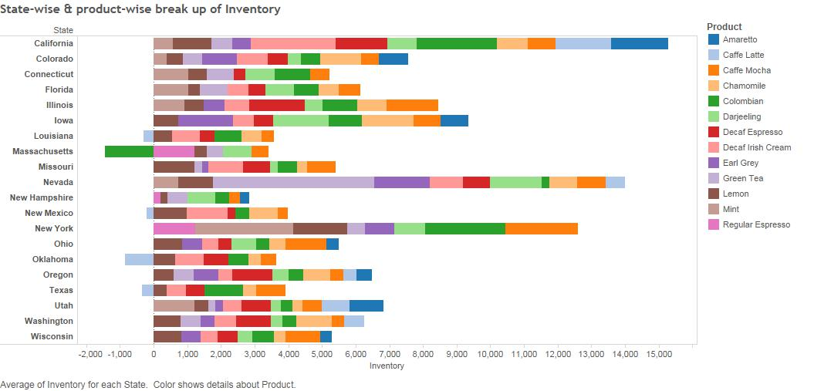
From above diagram, we can see that in Massachusetts, there is a negative inventory of Columbian Coffee. This can be interpreted as an unmet excess demand that needs to be satisfied by better inventory management.
We also find that, Nevada has the largest stock of Green Tea, which we know has poor sales. These inventory mismatches need to be reconciled.
What is the inventory position across the US?
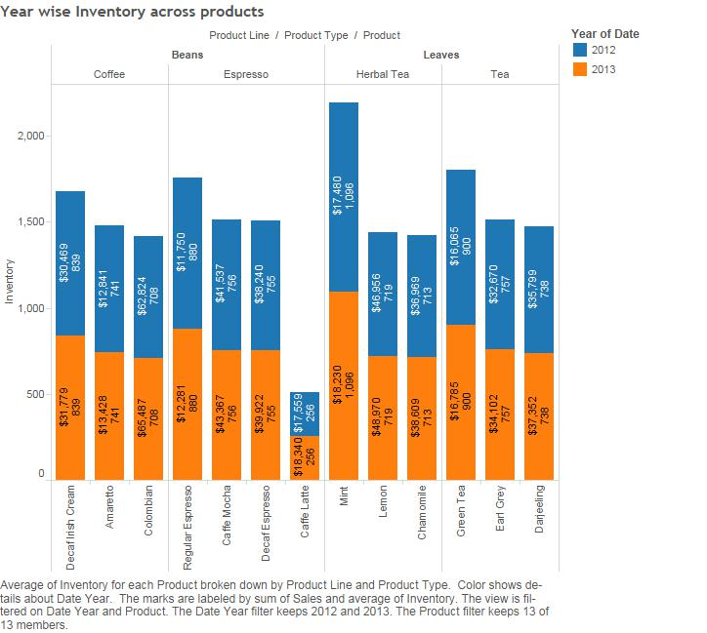
The above analysis shows us the aggregate inventory of all beverages across US. This is divided based on year categorical variable. We find that overall, in terms of volume; Caffe Latte has the lowest inventory and Mint has the highest, whereas both Caffe Latte and Mint have comparable sales, indicating a need for better control of Mint inventory.
Columbian Coffee has the best Sales and the high level of inventory in this case seems justified.

What is the inventory position across the US?

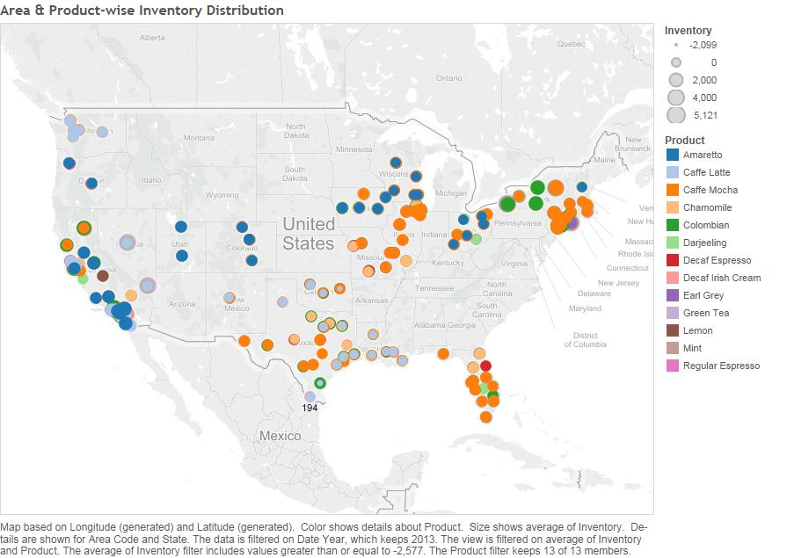
We can see from this mapping that, for example, distribution of Mint inventory is concentrated in the New York area while Amaretto and Caffe Latte are concentrated more around California, Washington and Oregon.
On the other hand, Earl Grey and Lemon Tea inventories are distributed across the country. Same is the case with Decaf Espresso and Columbian Coffee.
As such, our inventory management strategy should prioritize stocking the right products in the right quantities close to areas where sales for that product is high. Where sales and margins do not yield profits, holding inventory would result in higher expenses. Forecasting techniques may be used to achieve better inventory control.
Some improvement measures are intuitively visible, for example, we should hold Caffe Latte in California

What is the relationship of inventory with Sales and Profit Margins?

As such, we do not have access to price information of the inventory. So, for this analysis, we assumed prices of all products to be of comparable range. We have plotted the relationship of inventory as a percentage of Sales as well as of Profit Margin.
This result shows clearly that, like in the case of Green Tea, if Sales are low we get a steep ratio and as profit margins are negative or thin we get a reverse ratio. Hence, we should immediately reduce inventory of such products.
This is the case for Green Tea in Nevada, Amaretto in California and Café Mocha in New York.

Recommendations
- Products such as Decaf Irish Cream, Amaretto, Caffe Mocha, Mint and Green Tea which are consistently underperforming when compared with benchmark performance needs be given special focus. Costs should be cut down.
- Assuming benchmark performance levels defined by Coffee Company are based on Industry leader’s performance, Coffee Chain Company has a long way to go in optimizing its Cost of Goods expenses. It needs to optimize it supply chain and sourcing options to decrease COGS costs.
- As none of the companies can achieve desired gross margins but could achieve desired profit margins shows that middle managers tightening or decreasing Marketing spends to achieve desired profit margins. This can have negative effect on total sales that can be made by coffee chain. This should be addressed by the company.
- Stop products if prices cannot be increased in regions where the product is making negative margins.
- Increase prices or decrease expenses for product in regions where the product is making positive margins but negative profits.
- Decrease the marketing spend on Green Tea as it is consistently giving losses. Instead divert the resources to other products which have more potential for sales growth
- Marketing budget as a % of sales in most of the minor markets is very low if the market is a minor one. It is better for the company to recheck this policy as the states in minor markets where the spent higher share of marketing budget on sales are showing better profits. Example of such products are Café Latte, Columbian
- Café Latte is one of the products showing good profits. But the product is sold only in few areas in Western US. The company can rethink on selling it in East
- The marketing budget is constant from 2012 to 2013. This is same whether a product is selling well or not. Allocating marketing budget can be optimized to a great extend
- Products which are selling well, especially in major states are to be given boost by increasing the marketing sales %. This strategy can be experimented as it is currently unclear to what extent the marketing is effecting the sales values

